Time Complexity :

Time complexity tells us how much time an algorithm may take to solve a problem as the input size grows.
Instead of measuring the actual time in seconds (which can vary from one computer to another), we look at how the amount of work increases when the input becomes larger.
A good algorithm should finish its work in a reasonable and finite amount of time.
To estimate time complexity, we count:
- The important steps or operations performed by the algorithm.
- How many times those steps are repeated.
Example:
- If an algorithm checks every element in a list of 10 items, it performs 10 checks.
- If the list grows to 100 items, it performs 100 checks.
- This helps us understand how the algorithm's running time changes as the input size increases.
Agar abhi bhi confusion hai ki Time Complexity "time" hai ya nahi, toh simple answer hai:
Time Complexity directly seconds, milliseconds ya microseconds mein time nahi batati. Yeh batati hai ki algorithm ko problem solve karne ke liye kitna kaam (work) karna padega jab input size badhega.
Hum generally actual time ko measure nahi karte kyunki:
- Har computer ki speed alag hoti hai.
- Har programming language ki performance alag hoti hai.
- Same code different machines par different time le sakta hai.
Isliye actual seconds ki jagah hum number of steps or operations count karte hain.
Tum yeh maan sakte ho ki har elementary operation ek chhota time leta hai. Jitni zyada operations hongi, utna zyada time lagega. Isliye Time Complexity ko hum often "amount of work" ya "number of execution steps" ke roop mein dekhte hain.

Real-Life Analogy
Maan lo do students ek hi chapter padh rahe hain:
- Student A fast learner hai aur chapter 1 hour mein complete kar leta hai.
- Student B slow learner hai aur usi chapter ko 3 hours mein complete karta hai.
Dono ne same amount ka content padha hai, bas unki speed alag hai.
Isi tarah:
- Different computers ki speed alag ho sakti hai.
- Different programming languages ki performance alag ho sakti hai.
Lekin algorithm ko jo kaam karna hai (kitne steps execute karne hain), woh same rehta hai.
Time Complexity actual running time nahi batati, balki yeh batati hai ki input badhne par algorithm ka work kitni speed se grow karega.

Space Complexity

What is Space Complexity?
Space Complexity tells us how much memory (space) an algorithm may need to solve a problem as the input size grows.
Just as Time Complexity focuses on the amount of work performed, Space Complexity focuses on the amount of extra memory used by the algorithm.
A good algorithm should use memory efficiently and avoid wasting unnecessary space.
To estimate Space Complexity, we count:
- The variables used by the algorithm.
- Any extra arrays, lists, stacks, queues, or other data structures created.
- Memory used by function calls (recursion).

Example
int sum = 0;
for(int i = 0; i < n; i++) {
sum += arr[i];
}
Here, regardless of whether n = 10 or n = 1000000, we only use:
- sum
- i
The amount of extra memory remains the same.
Space Complexity = O(1) (Constant Space)

Another Example
int[] temp = new int[n];
for(int i = 0; i < n; i++) {
temp[i] = arr[i];
}
If:
- n = 10, we need space for 10 elements.
- n = 100, we need space for 100 elements.
- n = 1000, we need space for 1000 elements.
The memory requirement grows with the input size.
Space Complexity = O(n) (Linear Space)

Agar abhi bhi confusion hai ki Space Complexity "memory" hai ya nahi, toh simple answer hai:
Space Complexity directly MB, GB ya KB mein memory nahi batati. Yeh batati hai ki input size badhne par algorithm ko kitni extra memory chahiye hogi.
Hum generally actual memory usage ko measure nahi karte kyunki:
- Har system ki memory architecture alag ho sakti hai.
- Different programming languages memory ko alag tarike se manage karti hain.
- Same algorithm different platforms par thodi alag memory consume kar sakta hai.
Isliye actual memory units ki jagah hum extra memory growth ko measure karte hain.
Tum yeh maan sakte ho ki har variable ya data structure kuch memory leta hai. Jitni zyada extra memory allocate hogi, utni zyada space lagegi.
Isliye Space Complexity ko hum often "amount of memory required" ya "extra storage needed" ke roop mein dekhte hain.

Real-Life Analogy
Maan lo do students ek hi chapter padh rahe hain:

Student A
- Sirf textbook use karta hai.
- Extra notes nahi banata.
- Bahut kam desk space use karta hai.

Student B
- Textbook ke saath 5 notebooks use karta hai.
- Sticky notes lagata hai.
- Extra reference books rakhta hai.
Dono same chapter padh rahe hain.
Lekin Student B ko zyada space chahiye.
Isi tarah:
- Do algorithms same problem solve kar sakte hain.
- Dono ka output same ho sakta hai.
- Lekin ek algorithm extra arrays, stacks ya recursive calls use kare toh usse zyada memory lagegi.

Time Complexity vs Space Complexity
Time Complexity | Space Complexity
- Kitna work perform hoga | - Kitni memory use hogi
- Operations count karte hain | - Memory allocations count karte hain
- Execution speed ko represent karti hai | - Memory requirement ko represent karti hai
- Example: O(n), O(n²) | - Example: O(1), O(n), O(n²)

One-Line Defination for better understanding
"Space Complexity actual KB, MB ya GB ko measure nahi karti; yeh measure karti hai ki input size badhne par algorithm ko kitni extra memory ya storage ki zarurat padegi."

O(1) – Constant Time

Question 1
int sum (int a, int b) {
return a + b;
}

Analysis
Operations:
- One addition
- One return
No matter whether a = 5 or a = 5000000, the work remains the same.

Complexity
O(1)

Question 2
int getFirst(int[] arr){
return arr[0];
}

Analysis
Array indexing takes constant time.
Only one access:
arr[0]

Complexity
O(1)

O(log n) – Logarithmic Time

Question 3
int i = n;
while(i > 1){
i = i / 2;
}

Analysis
Suppose:
n = 16
16
8
4
2
1
Iterations:
16 = 2⁴
Number of divisions = 4
Generally:
k = log₂(n)

Complexity
O(log n)

Question 4
Binary Search
while(low <= high){
int mid = (low + high)/2;
if(arr[mid] == target)
return mid;
else if(arr[mid] < target)
low = mid + 1;
else
high = mid - 1;
}

Analysis
Each step removes half of the search space.
n
n/2
n/4
n/8
...
1
Number of halvings:
log₂(n)

Complexity
O(log n)

Question 5
for(int i = 1; i < n; i *= 2){
System.out.println(i);
}

Analysis
Values:
1
2
4
8
16
32
...
After k iterations:
2ᵏ = n
k = log₂(n)

Complexity O(log n)

Question 6
for(int i = 0; i < n; i++){
int j = n;
while(j > 1){
j /= 2;
}
}

Analysis
Outer loop:
n times
Inner loop:
log n
Total:
n × log n

Complexity
O(n log n)

Question 7
for(int i = 1; i <= n; i++){
for(int j = n; j > 1; j /= 2){
}
}

Analysis
Outer:
n
Inner:
log n
Multiply:
n log n

Complexity
O(n log n)

Question 8
for(int i = 0; i < n; i++){
for(int j = 1; j < n; j *= 2){
}
}

Analysis
Outer loop:
n
Inner loop:
1
2
4
8
16
...
n
Inner iterations:
log n
Total:
n × log n

Complexity
O(n log n)

Quick Formula Sheet
Pattern | Time Complexity
Single operation | O(1)
i /= 2 | O(log n)
i *= 2 | O(log n)
Binary Search | O(log n)
for(n) + while(i/=2) | O(n log n)
Merge Sort | O(n log n)
Heap Sort | O(n log n)
Nested loops n × n | O(n²)
Triple nested loops | O(n³)

Golden Rule
- Addition of loops → Take the larger complexity.
O(n) + O(log n)
= O(n)
- Nested loops → Multiply.
O(n) × O(log n)
= O(n log n)
- Halving or doubling repeatedly → Think log n.
n → n/2 → n/4 → n/8
⇒ O(log n) ✅

Asymptotic Notation

Big O notation
It describes “how code slows as data grows. “

- Describes the performance of an algorithm as the amount of data increases.
- Machine independent. ( Depend on the steps of completion )
- Ignore smaller operations O( n+ 1 ) -> O (n)

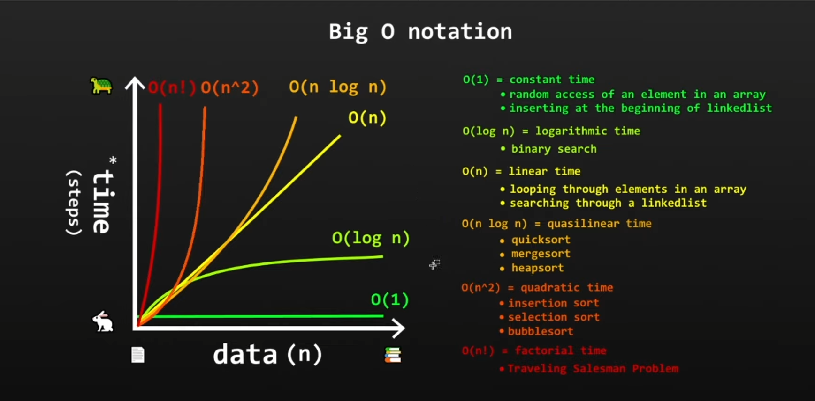

Θ (Theta) Notation
Theta Notation describes the exact growth rate of an algorithm.
While:
- Big O (O) tells us the maximum possible growth (Upper Bound).
- Omega (Ω) tells us the minimum possible growth (Lower Bound).
- Theta (Θ) tells us the actual growth when both upper and lower bounds are the same.

In Simple Words
Theta describes how code actually grows as data grows.

Characteristics
- Describes the exact performance of an algorithm.
- Machine independent.
- Represents both upper and lower limits together.
- Gives a tight bound on growth.

Example
for(int i = 0; i < n; i++){
System.out.println(i);
}
The loop executes exactly n times.
- Upper Bound = O(n)
- Lower Bound = Ω(n)
- Exact Growth = Θ(n)
Therefore:
Θ(n).

Ω (Omega) Notation
Omega Notation describes the minimum amount of work an algorithm will perform.
It gives the best-case or lower-bound growth.

In Simple Words
Omega describes how fast the code can be at minimum when data grows.

Characteristics
- Describes the minimum performance of an algorithm.
- Machine independent.
- Represents the lower bound.
- Shows the least amount of work that must happen.

Example
for(int i = 0; i < n; i++){
System.out.println(i);
}
No matter what happens, the loop must run n times.
Therefore: Ω(n)

Relation Between O, Θ and Ω
Operations

Easy Way to Remember
Notation | Meaning | Think As
O(n) | Upper Bound | "At most this much work"
Ω(n) | Lower Bound | "At least this much work"
Θ(n) | Exact Bound | "Actually grows like this"

Suppose you travel from Vadodara to Ahmedabad.
- Ω (Omega) = Best case: Road completely empty → 1.5 hours.
- O (Big O) = Worst case: Heavy traffic → 3 hours.
- Θ (Theta) = Typical/Expected journey → Around 2 hours.
So:
- Ω = Minimum possible time.
- O = Maximum possible time.
- Θ = Actual growth rate that closely describes reality.

One-Line Definitions
Big O (O): How much work the algorithm may do at most.
Omega (Ω): How much work the algorithm must do at least.
Theta (Θ): How much work the algorithm actually does as input grows.

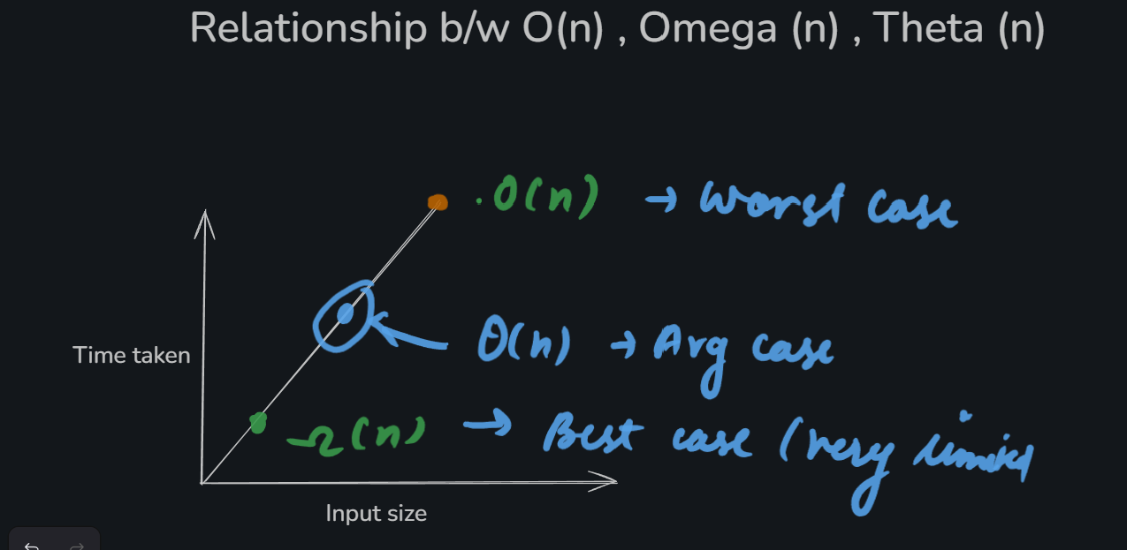

**For a equation the constants are ignore , it is easy to understand why added constants are ignored , but why the multiplicative constant are ignored ? This section will provide you with the proper understanding of this.
This is one of the most important questions in Big-O analysis.
You're right that 2n² is twice as much work as n². So why do we write both as O(n²)?

Short Answer
Because Big-O is interested in how fast the work grows, not the exact number of operations.
When n becomes very large, the shape of growth matters more than constant multipliers.

Let's Compare
Suppose:
- Algorithm A = n² operations
- Algorithm B = 2n² operations
n | n² | 2n²
10 | 100 | 200
100 | 10,000 | 20,000
1000 | 1,000,000 | 2,000,000
Yes, Algorithm B always does twice the work.
But notice something:
If n doubles:
n | n²
100 | 10,000
200 | 40,000
The work becomes 4 times larger.
The important factor causing this explosive growth is the n², not the 2.

Think of Growth Rate
Imagine:
n² and 2n²
Both curves have the same shape.
The second curve is just a little higher.

Operations
^
|
| 2n²
| /
| /
| /
| /
| /
| /
| / n²
| /
+------------------> n
As n grows, both are still quadratic curves.
So we say both have the same growth rate:
O(n²)

Why Do We Ignore 1 in n² + 1?
Consider:
n | n² | n² + 1
100 | 10,000 | 10,001
1000 | 1,000,000 | 1,000,001
The extra 1 becomes insignificant compared to n².
That's why:
n² + 1 → O(n²)

Why Do We Ignore 2 in 2n²?
Because Big-O only cares about growth category.
For example:
n²
2n²
100n²
0.5n²
All are quadratic.
All belong to:
O(n²)

But Doesn't 2 Matter in Real Life?
Absolutely!
If you are optimizing production code:
n² = 1,000,000 operations
2n² = 2,000,000 operations
The second algorithm is slower.
So constants matter for actual performance.
However, in algorithm analysis we usually ask:
"How does the algorithm behave when the input becomes very large?"
For that question, the constant 2 doesn't change the growth type.

A Better Analogy
Suppose:
- Car A drives at 60 km/h
- Car B drives at 120 km/h
Car B is twice as fast.
But if both travel from Delhi to Mumbai, the distance still grows linearly with the route length.
The factor 2 changes the speed, but not the type of growth.
Similarly:
- n² and 2n² have different speeds.
- But both grow quadratically.
Therefore:
2n² + 5n + 100
↓
O(n²)
because for very large n, the n² term dominates everything else.

Rule to Remember
When finding Big-O:
- Keep only the fastest-growing term.
- Remove all constants.
Examples:
n² + 1 → O(n²)
2n² → O(n²)
5n³ + n² → O(n³)
100n + 50 → O(n)
Big-O measures growth rate, not the exact running time. That's why constants like 2, 5, or 100 are ignored.

